**Q1. What is software? What is software engineering?**

**Answer.** A program or collection of programs with instructions that deliver desired functionality is referred to as **software**. The process of creating something that fulfils a specific need and finds an economical solution to issues is known as engineering.

**Software engineering** is the process of designing, creating, testing, and maintaining software. It is an organised, systematic approach to software development to produce dependable, high-quality, and maintainable software.

**Q.2 Explain the types of software**

Numerous industries, including healthcare, banking, education, defence, finance, the stock market, and more, heavily rely on the software. It can be divided into several kinds:

1. System Software: System software is required to support the execution of application programs and manage computer resources. This group includes programs such as operating systems, compilers, editors, drivers, and so forth. These are essential to the operation of a computer. Operating systems are necessary to connect a program's machine-dependent requirements with the hardware of the computer it runs on. Programmes written in high-level languages are translated into machine language by compilers.
2. **Application software** is made to directly communicate with users in order to satisfy their needs. Application software, the most popular kind of software, is a computer software package that works with another application or for the user in certain situations. Applications can be standalone or comprise a collection of programmes that execute the application on the user's behalf. Office suites, graphics software, databases and database management systems, web browsers, word processors, software development tools, picture editors, and communication platforms are a few examples of contemporary applications.
3. **Driver software**. Also known as device drivers, this software is often considered a type of system software. Device drivers control the devices and peripherals connected to a computer, enabling them to perform their specific tasks. Every device that is connected to a computer needs at least one device driver to function. Examples include software that comes with any nonstandard hardware, including special game controllers, as well as software that enables standard hardware, such as USB storage devices, keyboards, headphones and printers.
4. **Middleware.** The term middleware describes software that mediates between application and system software or between two different kinds of application software. For example, middleware enables Microsoft Windows to talk to Excel and Word. It is also used to send a remote work request from an application in a computer that has one kind of OS, to an application in a computer with a different OS. It also enables newer applications to work with legacy ones.
5. **Programming software**. Computer programmers use programming software to write code. Programming software and programming tools enable developers to develop, write, test and debug other software programs. Examples of programming software include assemblers, compilers, debuggers and interpreters.

**Q 3. What is SDLC? Explain each phase of SDLC**

SDLC: The Software Development Life Cycle is a process used by software development companies to plan, design, develop, test, deploy and maintain software applications.

In The **Plan Phase**, it involves gathering and analysing information about the software requirements from stakeholders, such as customers, end-users and business analysts.

Wherein Design Phase, the software design is created, which includes the overall architecture of the software, data structures and interfaces. It has two steps:

* High-Level Design (HLD): It gives the architecture of software products.
* Low-Level Design (LLD): It describes How each feature in the product should work and every component.

The design is then translated into code, typically through several iterations; this phase is also known as **Development Phase**.

Things to be aware of during this stage:

* In the SDLC model, this is the longest phase.
* Middleware, Backend, and Front End make up this phase.
* On the front end: Coding development is completed, including setting up SEO.
* Middleware serves as a bridge between the front and back ends.
* A database is created on the back end.

To make sure the software satisfies the specifications and functions as intended; it is extensively tested during the **Testing Phase.**

Following a successful testing phase, the software is made available to end users and deployed to a production environment in the **Deployment phase.**

And The last Phase which entails regular software updates, bug patches, and support is called The **Maintenance Phase.**

**Q 4. What is DFD? Create a DFD diagram on Flipkart.**

The acronym for a data flow diagram is DFD. DFD represents the data flow of a system or process. It also provides information about each entity's inputs, outputs, and the process itself. DFDs use hierarchy to maintain transparency thus multilevel DFDs can be created. It is a graphical representation that is very easy to understand as it helps visualize contents. The data Flow Diagram represents a detailed and well-explained diagram of system components.

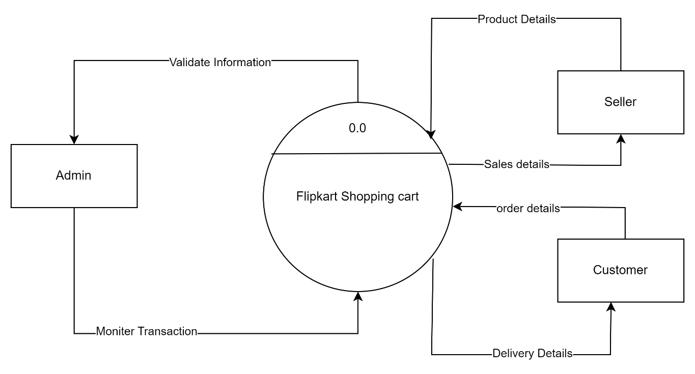

**Level 0 DFD of Flipkart**

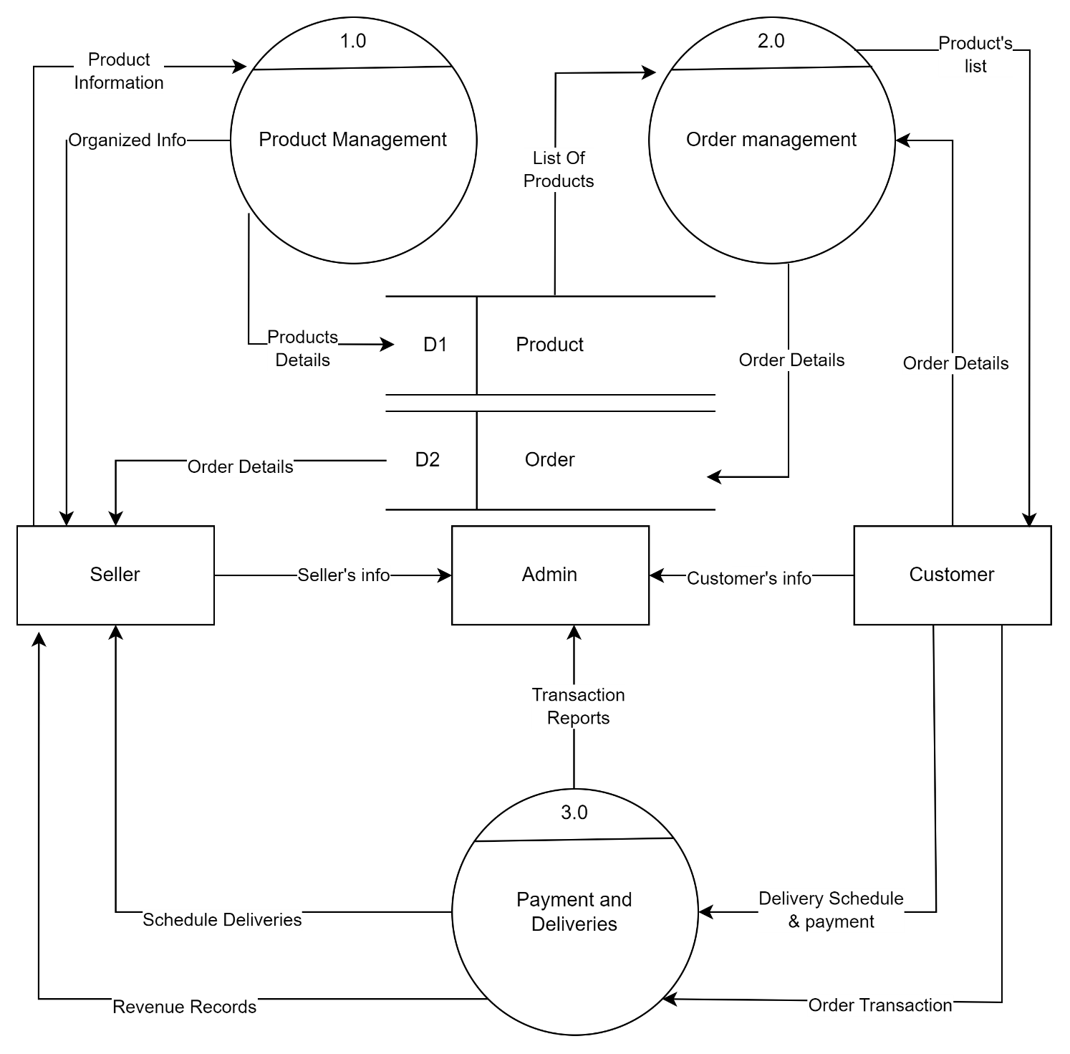

**Level 1 DFD of Flipkart**

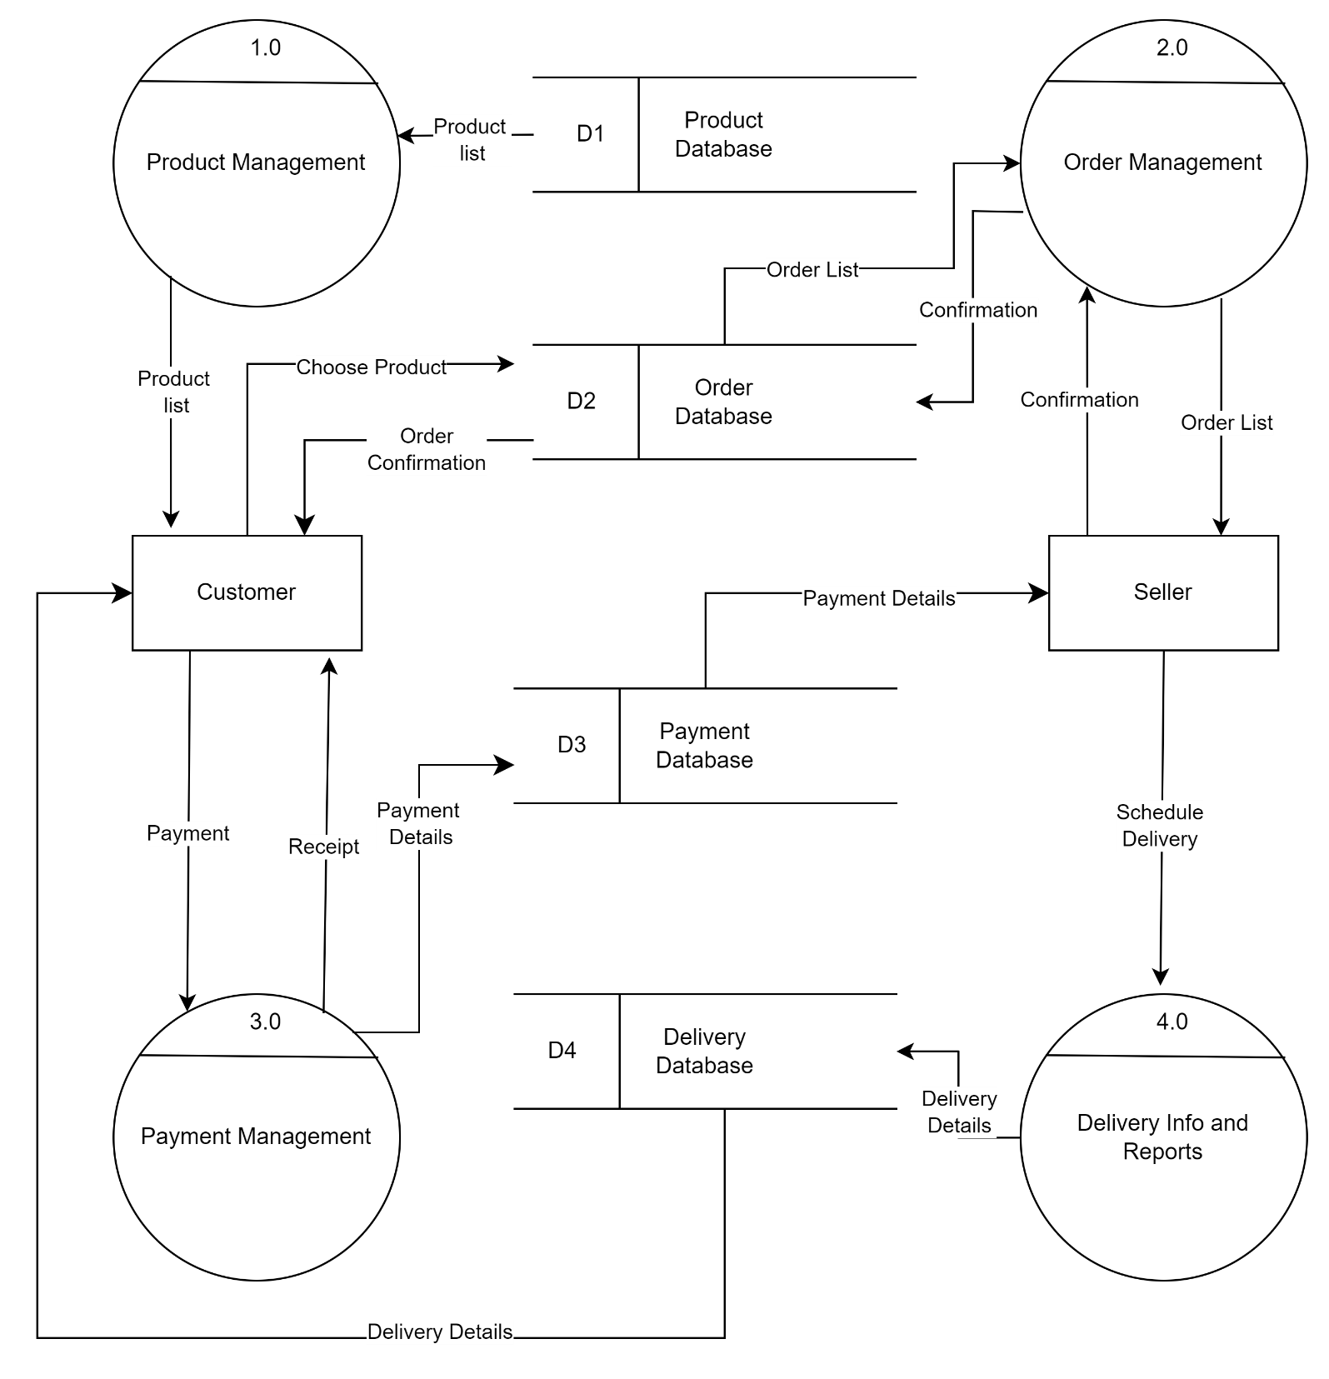

**Level 2 DFD of Flipkart**

**Q5. What is a Flow chart? Create a flowchart to make the addition of two numbers.**

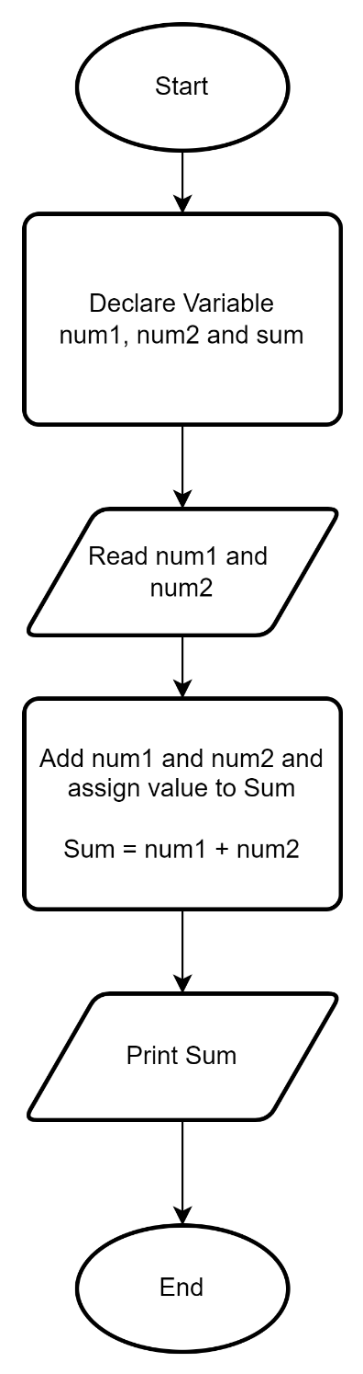**Answer**: All flowcharts are a graphical depiction of the data or algorithm to aid in the visual comprehension of the code. It presents methods, algorithms, or problem solutions step-by-step. It is a visual representation of the steps that most programmers at the beginning of the process find most helpful in understanding computer science algorithms, which helps debug the algorithm. An image of boxes showing the sequential process flow is called a flowchart. A flowchart makes a process or algorithm easy to interpret and comprehend because it is a visual representation of the process.

**Fig: Flowchart to make**

**the addition of two**

**numbers.**

**Q 6. What is a Use case Diagram? Create a use-case on bill payment on Paytm.**

**Answer:** The Use-Case Diagram is used to prepare, present and understand the functional requirements of the system. Use-case Diagram specifies the exact context of the software being developed. It does not specify the order in which actions must be performed.

System

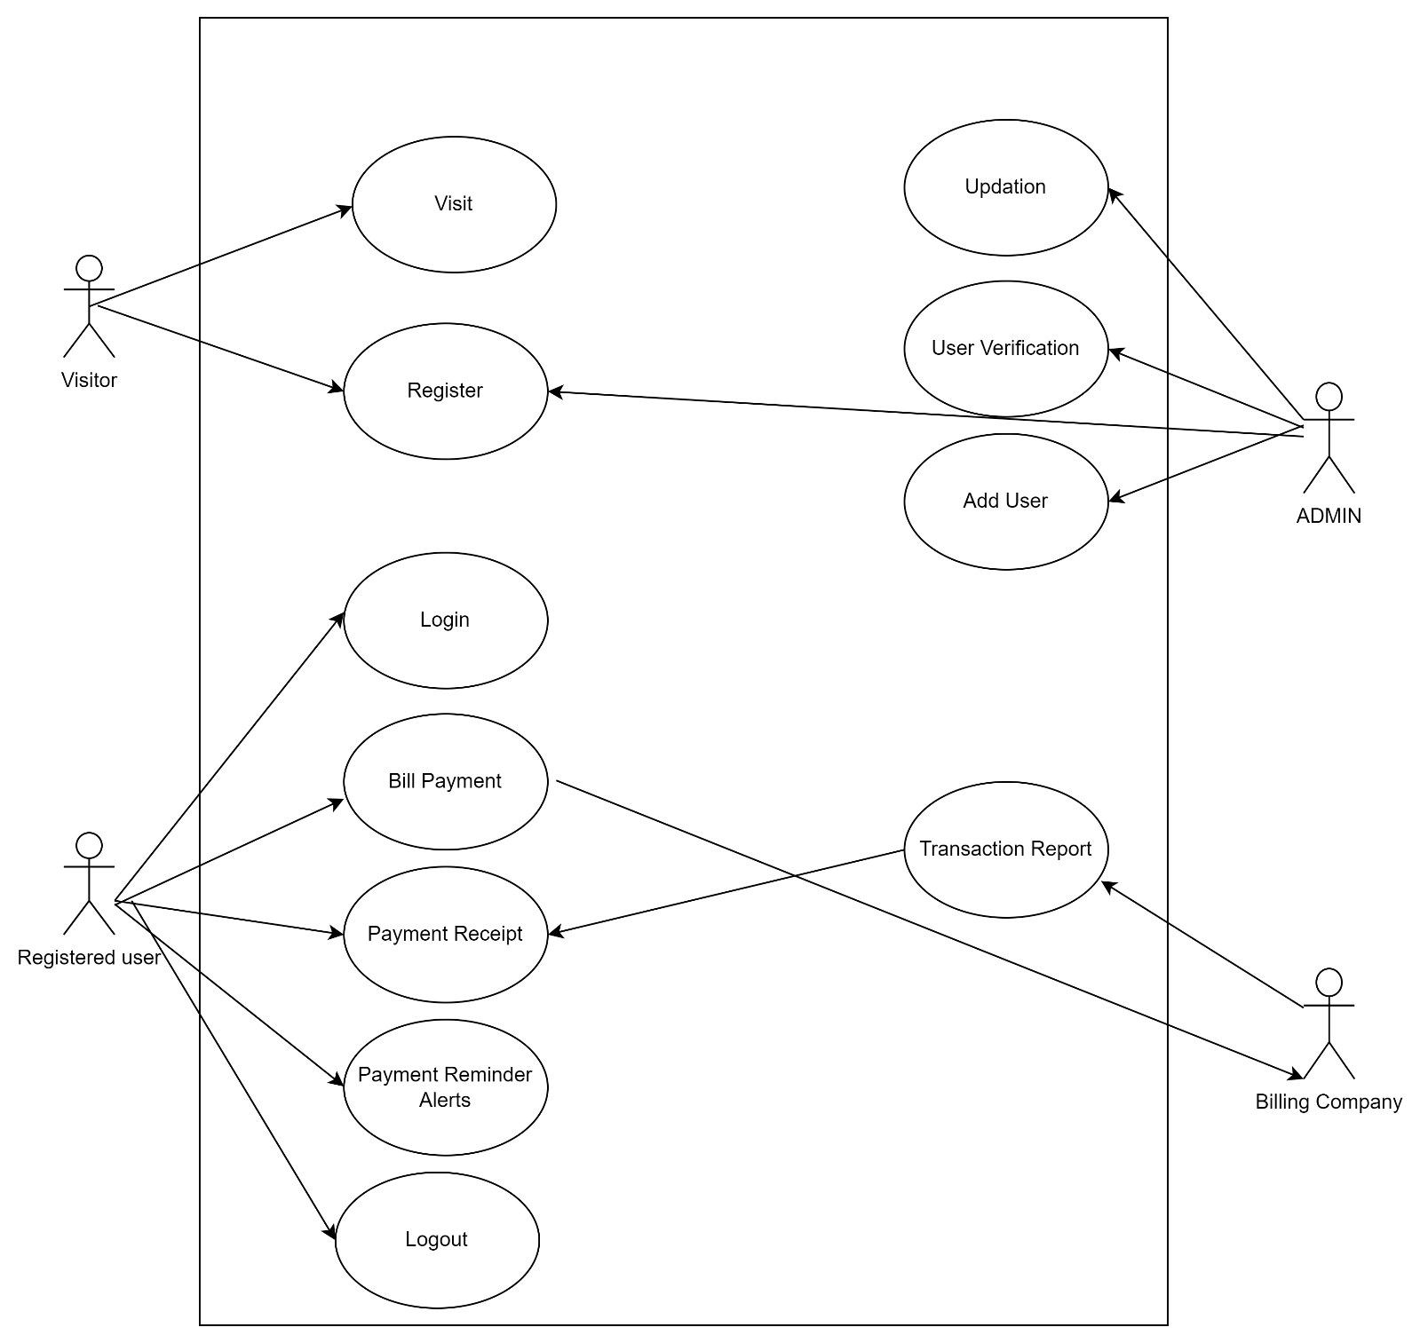

**Use Case Diagram Of Paytm Bill Payment System**